Lab 3
Solve the below series circuit. To find unknown quantities as mentioned in worksheet. Choose the values of resistors of your own choice.

Voltages Through Multisim:
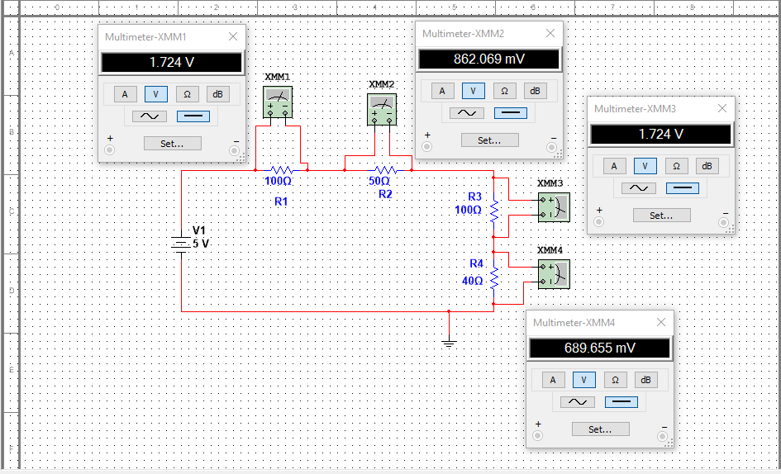

Current through Multisim:
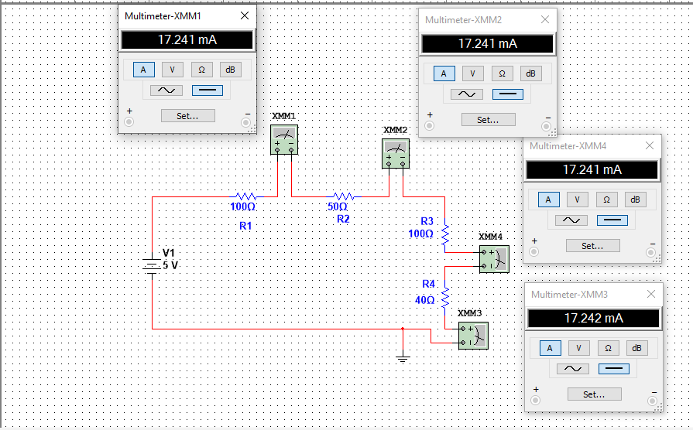
Voltages and Current Manually Calculated:
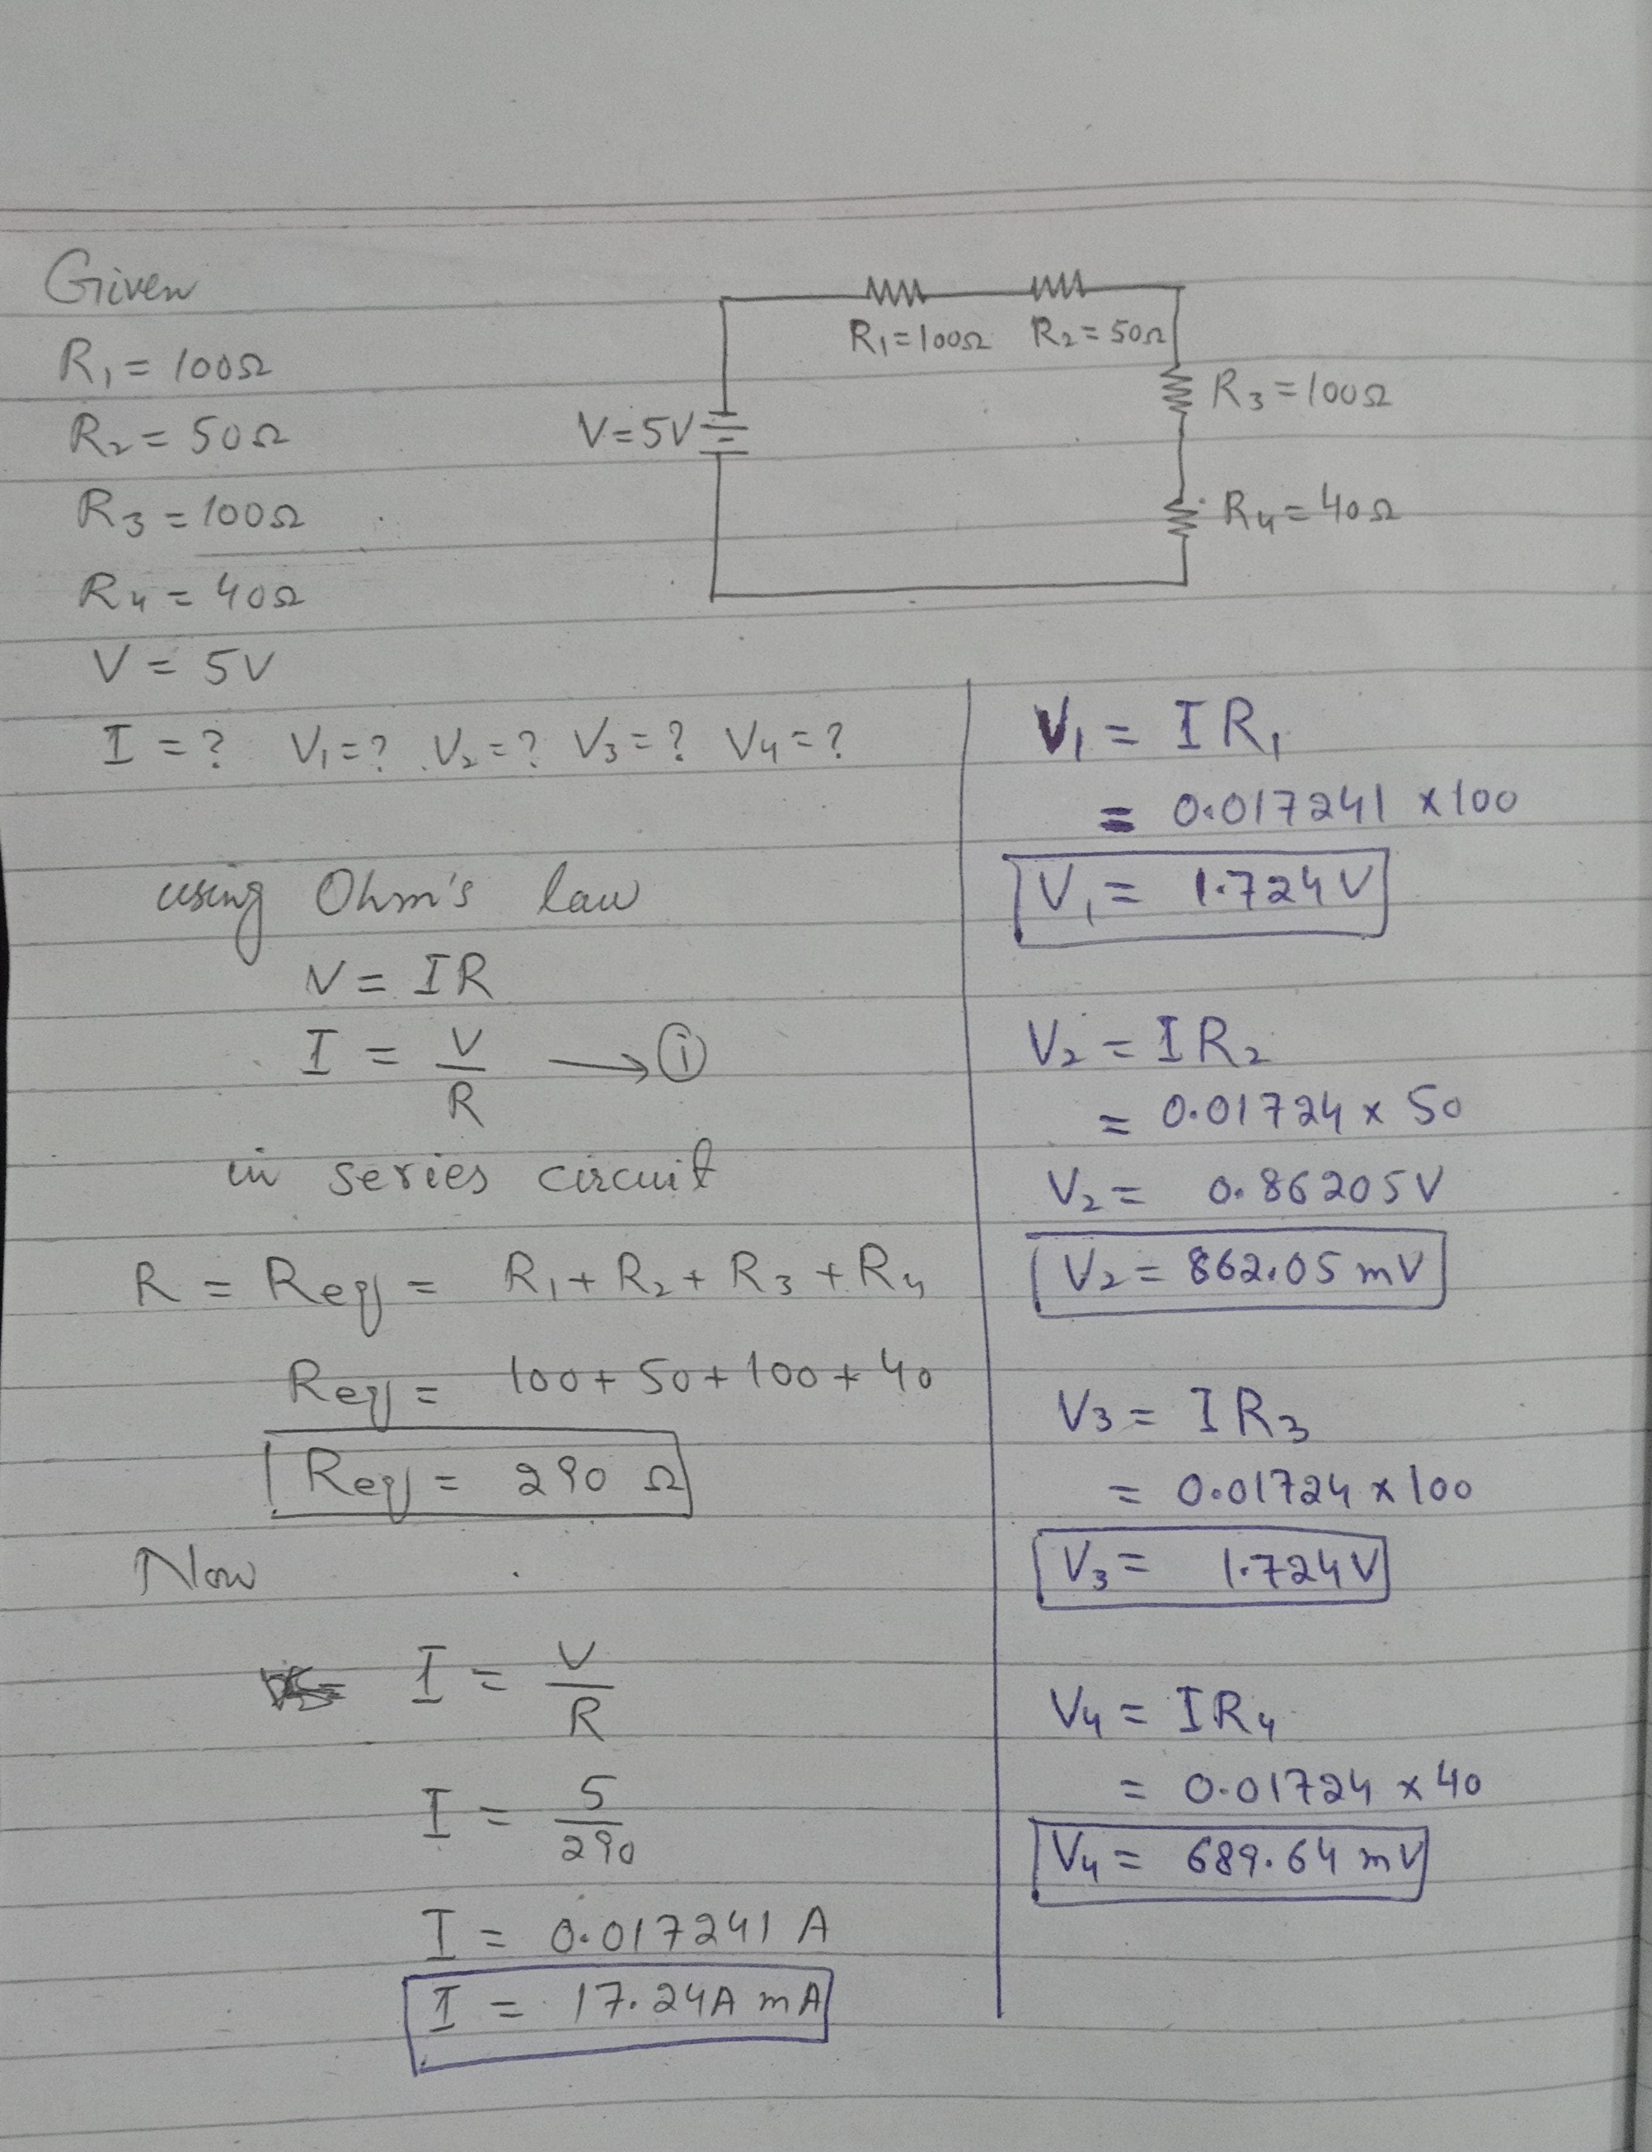

Procedure: Determining Equivalent Resistance-Series Arrangement
- Connect the two resistors in a series arrangement.
- Supply 5V to the circuit
- Find the values of four resistors
- Find the voltage and current across R1, R2, R3, and R4

Worksheet
Table 1
Resistors | R1 | R2 | R3 | R4
R (Nominal) | 100 ohm | 50 ohm | 100 ohm | 40 ohm
R (Actual) | 92 ohm | 59 ohm | 102 ohm | 38 ohm

Table 2
Values | I | V₁ | V₂ | V₃ | V4
Calculated | 17.241mA | 1.724V | 862.05mV | 1.724mV | 689.64mV
Measured | 17.241mA | 1.724V | 862.069mV | 1.724V | 689.655mV

